**ERP SYSTEM**

DATABASE DESIGN

**INVENTORY**

* **User Login**
* **Key Info**
* **Customer**
* **Supplier**
* **Item**
  + Item attribute
  + Category (1,2,3 etc)
  + position
  + Tax
  + HSN code(if)
* **Sales Order**
* **Purchase Order**
* **Sales**
* **Purchase**
* **Accounts**
* **Tax Data**
* **Print (.rpt)**

**User Login**

**Error (**Exit**)**

**Check Validity**

Username

Password

**User Home Page**

**Customer**

Customer

Customer Details

**Supplier**

Supplier

Supplier Details

**Salesmen**

Supplier

**Tax**

Tax rule

Tax Details

**Item**

**Category**

**(cat1,2,3)**

**Item Name**

**Tax from**

**Taxdata**

**Salesman, area**

**Sales**



Reports

Reports review

Feedback

Feedback

Feedback

Sales and Inventory Management

System

Transaction Checking

Feedback Reports Review

Items Information

Account Details

Feedback

Admin

Sales Manager

Salesmn/cstmr

Inventory Manager

Sales 1.0

Login Customer

Customer info

7. Add new

Customers

Username, Password

Feedback

Feedback

New Info

Items info

2. Change 3. View Items

Information info

Feedback Request

Request help

Report

details

Feedback

Bill Details (id, date, item, ect…)

6. Get Help

Help

5. Sales Order

S

Reports

4. Create Bill

Sales

SL 1.1

**Authentification**

**1.**Login System

Check Username, Password

Logout

Users

Username, Password

Feedback

Customer

IM System

SL 1.2

**Purchase**

Login Supplier

Customer info

7. Add new

Customers

Username, Password

Feedback

Feedback

New Info

Items info

2. Change 3. View Items

Information info

Feedback Request

Request help

Report

details

Feedback

Bill Details (id, date, item, ect…)

6. Get Help

Help

5. PO

S

Reports

4. Create Bill

Purchase

PR 1.1



Reports

Reports review

Feedback

Feedback

Feedback

Purchase and Inventory Management

System

Transaction Checking

Feedback Reports Review

Items Information

Account Details

Feedback

Admin

Purchase Manager

supplier

Inventory Manager

**Authentication**

**1.**Login System

Check Username, Password

Logout

Users

Username, Password

Feedback

Supplier

IM System

PR 1.3

**Stock**

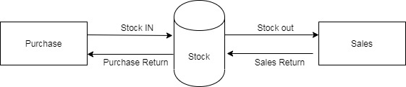

Stock 1.0

**Accounts**

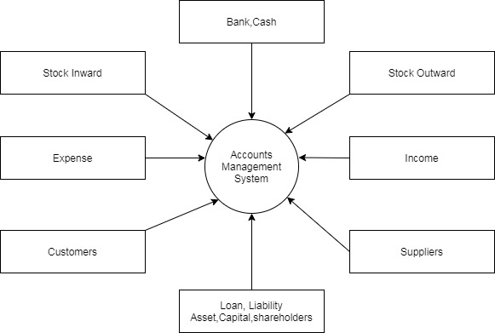

ACC 1.0

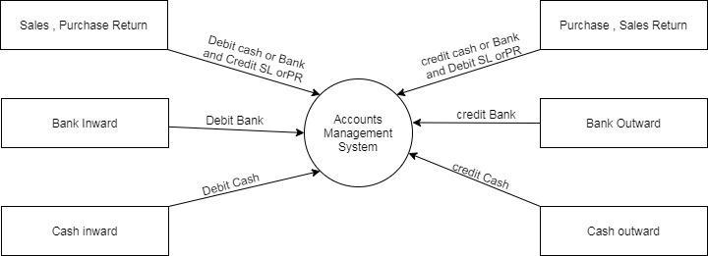

Acc 1.1

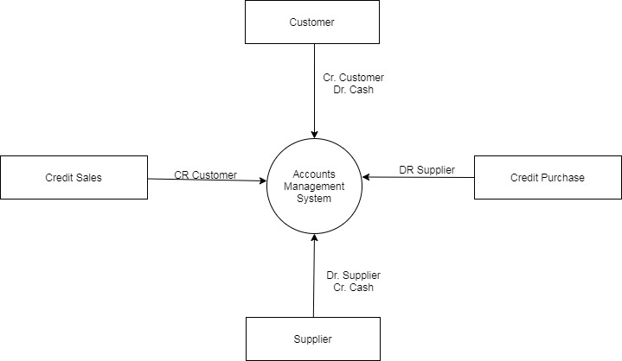

Acc 1.2

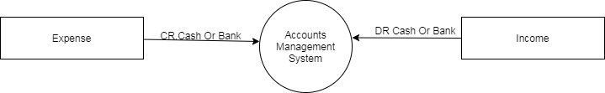

Acc 1.3

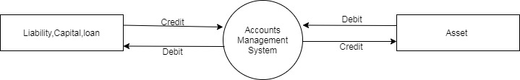

Acc 1.4

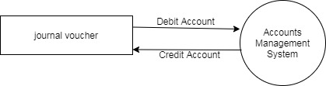

Acc 1.5

**Reports**

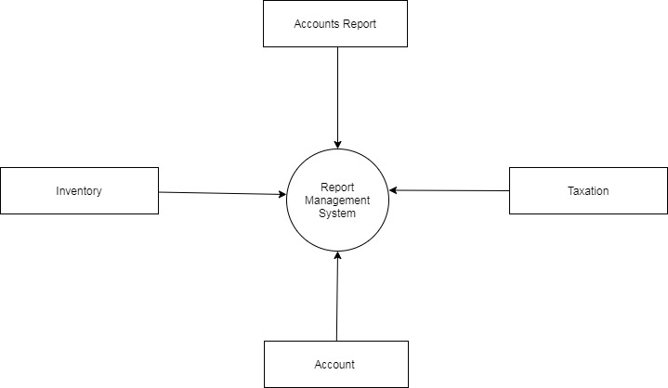

CR 1.0

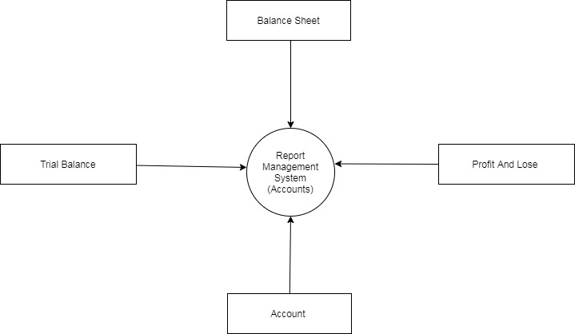

CR : 1.1

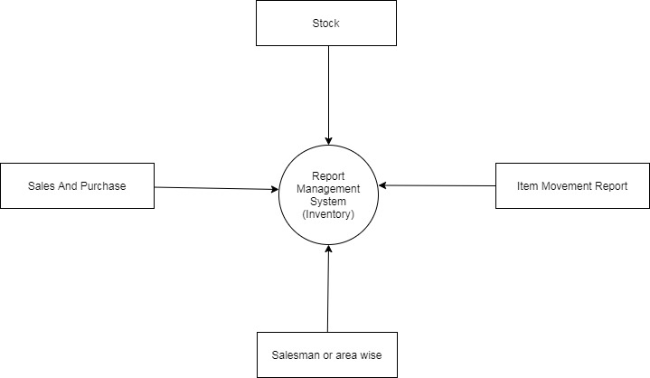

CR : 1.2

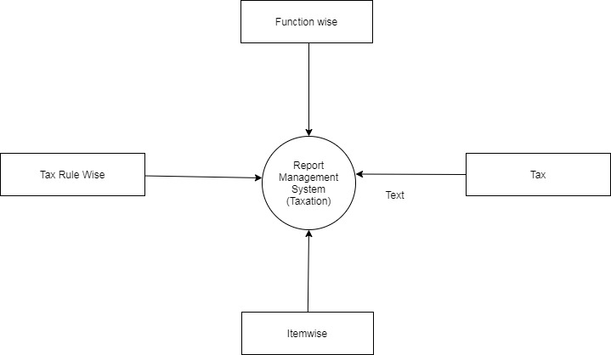

CR 1.3

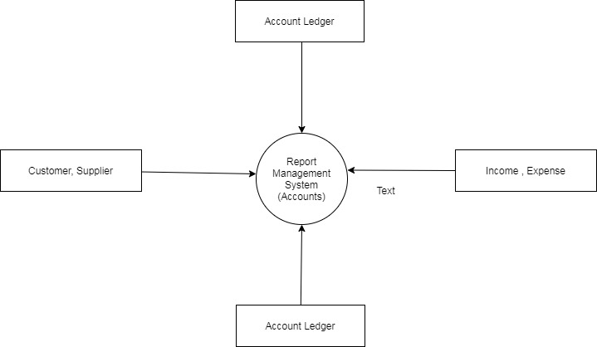

CR 1.4

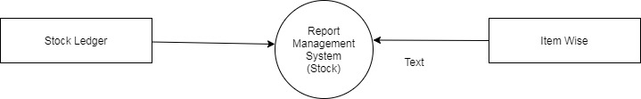

CR : 1.5

**Opening**

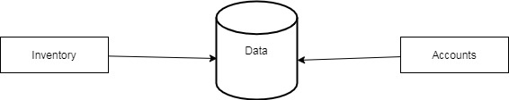

OP 1.0

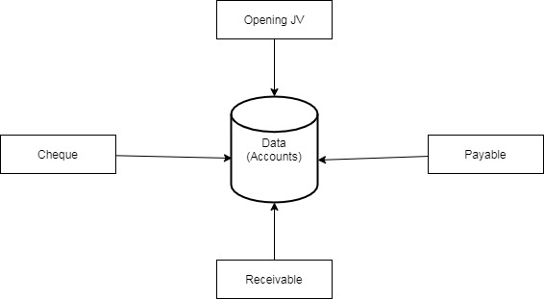

OP 1.1

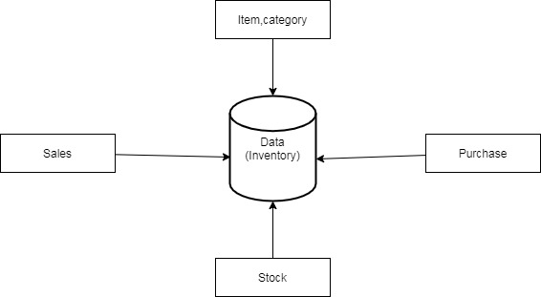

OP 1.1

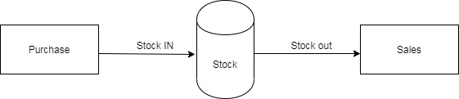

OP 1.2

**Data Base Design**

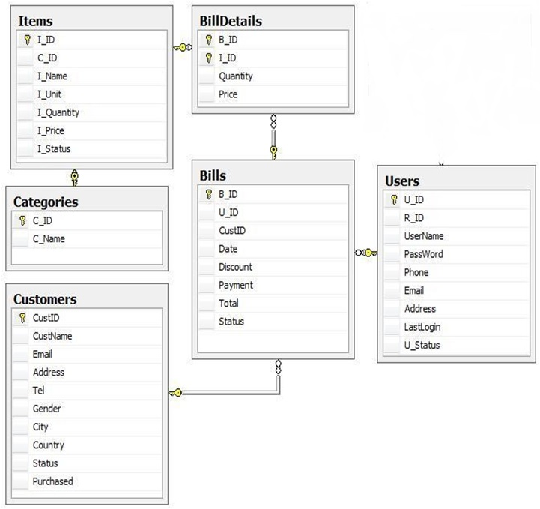

**Database Structure**

|  |  |  |  |  |
| --- | --- | --- | --- | --- |
| Table Customers | | | | |
| Fields Name | Data Type | Null | Key | Description |
| Cust_ID | int | No | Primary key | Identity, Store the Id of Customer |
| Cust_Name | nvarchar(50) | No |  | Store name of Customer |
| Tel | varchar(12) | No |  | Store contact phone of Customer |
| Address | nvarchar(50) | No |  | Store address of Customer |
| Gender | bit | Yes |  | Store gender of Customer |
| Purchased | float | No |  | Store number of purchasa |
| Status | Bit | No |  | Store status of Customer |
| City | nvarchar(20) | Yes |  | Store City of Customer |
| Country | Nvarchar(30) | Yes |  | Store Country of Customer |

|  |  |  |  |  |
| --- | --- | --- | --- | --- |
| Table Users | | | | |
| Fields Name | Data Type | Null | Key | Description |
| U_ID | varchar(5) | No | Primary key | Store Id of User |
| R_ID | Varchar(5) | No | Foreign key | Reference Roles table |
| UserName | varchar(30) | No |  | Store username of User |
| PassWord | Varchar(16) | No |  | Store password of User |
| Name | Nvarchar(50) | No |  | Store Name of User |
| Phone | varchar(12) | No |  | Store contact phone of User |
| Email | Varchar(30) | No |  | Store contact Email of User |
| Address | Nvarchar(50) | No |  | Store address of User |
| LastLogin | DateTime | No |  | Store the last time when User login to system |
| U_Status | int | No |  | Store status of User, Default 1 |

|  |  |  |  |  |
| --- | --- | --- | --- | --- |
| Table Items | | | | |
| Fields Name | Data Type | Null | Key | Description |
| I_ID | varchar(5) | No | Primary key | Store Id of Item |
| C_ID | Int | No | Foreign key | Store ID of Category Contain Item |
| I_Name | nvarchar(25) | No |  | Store name of Items |
| I_Unit | Varchar(15) | No |  | Store measure of Item |
| I_Price | Float | No |  | Store price of Item |
| I_Quantity | int | No |  | Store quantity of Item in stock |
| I_Category | Varchar(15) | NO |  | May be brand Or Attitude of the product |
| I_Status | int | No |  | Store status of Item |
| Rack | Int | yes |  | Storing Possition |

|  |  |  |  |  |
| --- | --- | --- | --- | --- |
| Table Categories | | | | |
| Fields Name | Data Type | Null | Key | Description |
| C_ID | int | No | Primary key | Identity, Store ID of Category |
| C_Name | nvarchar(30) | No |  | Store Name of Category |

|  |  |  |  |  |
| --- | --- | --- | --- | --- |
| Table Bills | | | | |
| Fields Name | Data Type | Null | Key | Description |
| B_ID | int | No | Primary key | Identity, store Id of Bill |
| U_ID | varchar(5) | No | Foreign key | References U_ID field on Users table |
| Cust_ID | int | No | Foreign key | References Cust_ID field on Customers table |
| Date | datetime | No |  | Store purchased date |
| Tax | Float | No |  | Store the Tax of Item |
| Discount | float | No |  | Store the discount of Item |
| Payment | nvarchar | No |  | Store payment of transactions |
| Total | float | No |  | Store total price |
| Status | bit | No |  | Store status of this order |

|  |  |  |  |  |
| --- | --- | --- | --- | --- |
| Table BillDetails | | | | |
| Fields Name | Data Type | Null | Key | Description |
| B_ID | Int | No | Foreign key | Reference B_ID field of Bills table |
| I_ID | varchar(5) | No | Foreign key | Reference I_ID field of Items table |
| Price | float | No |  | Store price of this Bill |
| Quantity | int | No |  | Store quantity of this Bill |
| Primary key of this table is a synthesis of two key fields B_ID and I_ID | | | | |

|  |  |  |  |  |
| --- | --- | --- | --- | --- |
| Table Accounts | | | | |
| Fields Name | Data Type | Nul | Key | Description |
| B_ID | Int | No | Foreign key | Reference B_ID field of Bills table |
| I_ID | varchar(5) | No | Foreign key | Reference I_ID field of Items table |
| Amount | float | No |  | Store price of this Bill |
| Description | varchar(50) | No |  | Store Description of this Bill |
| Function Code | varchar(5) | No |  | Store Fn Code of this Bill |
| Sign | Int(1) | No |  | Eg: if credit value will be -1 else 1 |
| Primary key of this table is a synthesis of two key fields B_ID and I_ID | | | | |

Cancel produced bill and take back Items

Start

Select Bill from Bills

Data Error

True

Cancel Bill

False

True

Display Message

Stop

Add this Item’s number to the same Item in Items table

Update this Bill’s Status =1 in Bills table, count item’s number in this bill

Check Bill data

**Search Item**

Start

Input Keyword for

Search

False

Validate input

Data

True

Display Error

Message

False

Data found

True

Display result

Stop

Search on Items table by Keyword

**Function of Salesman**

Display all status of Items

Get all Items that are not available, need to be stocked

Start

Select status of all Items in Items table

Stop

Inform the Inventory Manager about those Items

**Change Item Price**

Start

Input new Items’

Price

False

Validate input

data

Error msg

True

Choice Items which change price

Display Success

Message

Stop

Update Items price

**Function of Sales Manager**

Check bills are created in day

Display numbers

of Bills

Stop

Start

Count numbers of Bills are generated in Order table

Check moneys are transacted in day

Start

Count sum of money are transacted in Order table

Display sum of

money

Stop

Check Bills are cancelled in the day

Start

Count numbers of Bills are cancelled in the day in Order table

Display numbers

of Bills

Stop

Check Items are returned in the day

Display numbers

of Items

Stop

Count numbers of Items in these Bills



Start

Count numbers of Bills are cancelled in the day in Order table

